Explainable AI Email Triage: Final Technical Report
Keith G. Broussard
University of the Cumberlands
MSAI 699-B01: Capstone
Dr. Gamini Bulumulle
August 16, 2026

Explainable AI Email Triage: Final Technical Report
Important messages can be buried in high-volume inboxes, but automating urgency creates competing risks. False negatives can delay action on deadlines, security incidents, or operational problems; false positives can increase review burden until prioritization becomes meaningless. This capstone asks whether an explainable text-classification workflow can help a person identify potentially urgent organizational email without transferring the final decision to software. Under the project's labeling guide, urgent means the recipient faces an imminent deadline, an active incident, or a meaningful consequence from delay. Routine, optional, resolved, or time-insensitive messages are nonurgent.
The intended workflow is bounded decision support. The system combines an email subject and body, converts the text to term frequency-inverse document frequency (TF-IDF) features, applies logistic regression, and returns an urgency probability, a threshold-based classification, and the strongest learned terms supporting or opposing the score. A reviewer evaluates that evidence and makes the final decision; the software does not send, suppress, or automatically act on email. The original proposal included urgency, topic, and required-action classification, but implementation was narrowed to binary urgency so labeling, modeling, explanation, and evaluation could be completed with defensible evidence. The Enron corpus supplied authentic organizational language, although its age and context limit generalization (Cukierski, 2016; Klimt & Yang, 2004).
Development proceeded through three evidence checkpoints: a Week 3 baseline, Week 4 training-pipeline optimization, and Week 6 nested threshold testing and error analysis. These labels mark successive experimental stages, not separate systems. This report integrates the evidence and evaluates predictive reliability and software reproducibility. The Week 6 disposition remains revise. Software validation prepares the repository for the planned Week 8 demonstration; it does not approve shadow testing or deployment.
Methodology
The Kaggle distribution of the Enron Email Dataset contains 517,401 source records. Raw messages remained local and outside Git; the reviewed manifest retained identifiers, sampling strata, approved labels, versions, and review status. Human review followed labeling-guide version 1.0, and unresolved needs_review records were excluded from modeling. The final binary sample contained 199 reviewed messages: 169 nonurgent and 30 urgent. General-random and urgency-enriched sampling supplied enough positive examples for a prototype, so the 15.1% urgent share is not an estimate of mailbox prevalence.
Subject and body text were combined inside a scikit-learn pipeline so TF-IDF fitting occurred only on training data (Pedregosa et al., 2011). A fixed stratified split used 159 training messages and a 40-message preliminary holdout with random_state = 42. Comparisons covered a majority dummy and unweighted and class-balanced logistic regression. Because the holdout influenced early model selection, later reports identify it as preliminary rather than untouched final evidence.
Week 4 evaluated 24 class-balanced configurations with five-fold stratified cross-validation on the training partition. Urgent F1 was primary; recall, accuracy, feature count, and timing were supporting measures. The retained candidate used C = 0.1, unigram TF-IDF, min_df = 2, English stop-word removal, and sublinear term frequency. SHAP values were treated as learned feature contributions, not causal explanations (Lundberg & Lee, 2017).
Week 6 froze the candidate and used five outer and four inner stratified folds. Inner folds tested thresholds from 0.20 through 0.50; outer labels were not used for threshold selection. Urgent F1 ranked thresholds, followed by recall, fewer false positives, and the higher threshold. The 40-message holdout was scored once only after the procedure and revise decision were frozen. Executed notebooks, aggregate CSV files, privacy-safe error records, figures, decision files, environment versions, and SHA-256 hashes support reproduction.
Results
Table 1
Project Performance and Decision Evidence
Stage | Urgent recall | Urgent F1 | Decision evidence
Week 3 holdout | 33.3% | 44.4% | 4 urgent FN; preliminary
Week 4 baseline CV | 4.0% | 6.7% | Frozen comparison
Week 4 candidate CV | 8.0% | 11.4% | Retain for refinement
Week 6 CV, threshold .45 | 100.0% | 26.2% | 135 FP; all urgent
Week 6 CV, threshold .50 | 8.3% | 15.4% | 22 urgent FN
Note. CV = cross-validation; FN = false negatives; FP = false positives. Week 3 holdout evidence is descriptive because it informed exploratory model selection.
The Week 3 class-balanced baseline reached 87.5% holdout accuracy, but urgent recall was 33.3% and four of six urgent messages were missed. Week 4 training cross-validation increased mean urgent F1 from 6.7% to 11.4%, recall from 4.0% to 8.0%, and accuracy from 83.7% to 86.2%, while reducing features from 4,097 to 2,895. The preliminary holdout repeated the tradeoff. At 0.45, all 40 messages were labeled urgent, producing 34 false positives. At 0.50, two of six urgent messages were found, with four false negatives and one false positive.
Across 159 outer-fold predictions, threshold 0.45 found all 24 urgent messages but labeled all 159 urgent, creating 135 false positives. Threshold 0.50 produced no false positives but found only two urgent messages and missed 22. Of 159 probabilities, 157 fell from 0.45 to below 0.50. ROC AUC was 0.715 and average precision was 0.388, but the Brier score was 0.237 versus 0.128 for a constant prevalence estimate. These results support calibration analysis and revision, not post hoc threshold adjustment.
Figure 1
Training Out-of-Fold Threshold Tradeoff
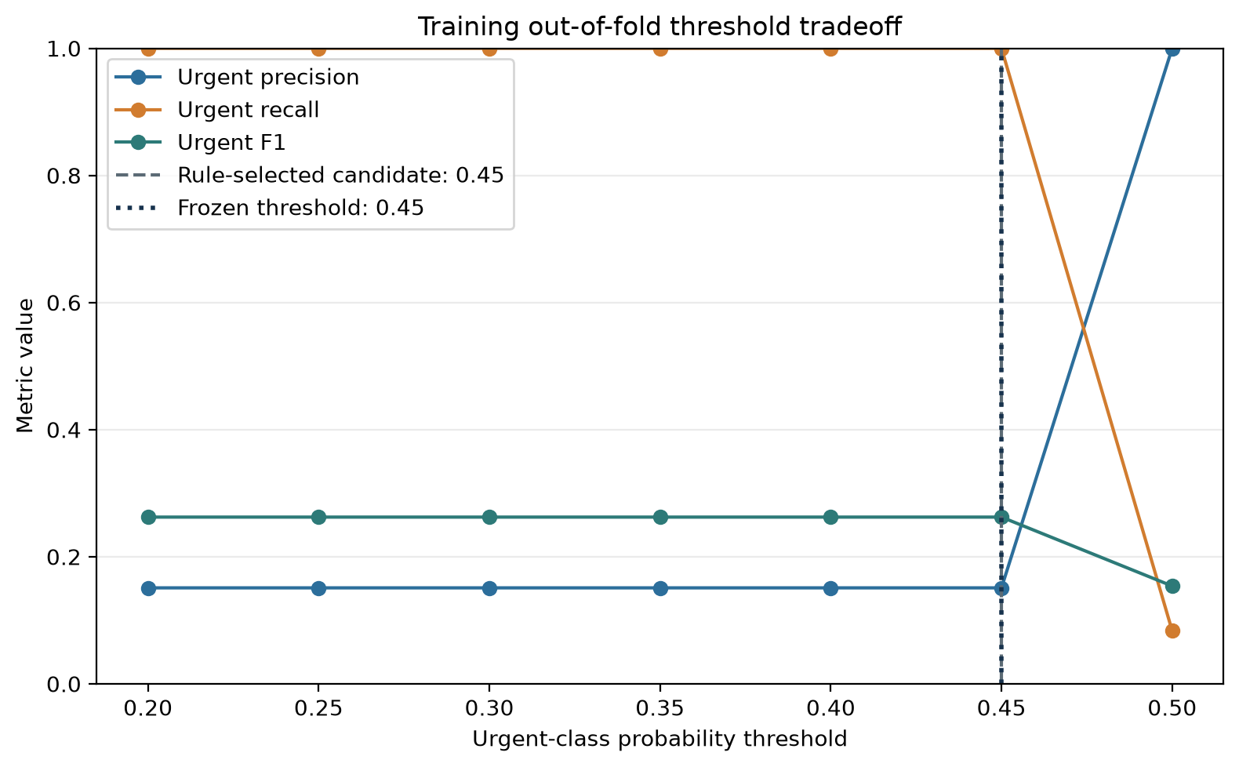
Note. Thresholds from 0.20 through 0.45 produced identical all-urgent predictions. The apparent recall gain at 0.45 therefore eliminated useful triage rather than improving operational reliability.
Discussion
The interpretable pipeline was reproducible, but favorable metrics could not be separated from error counts and operational consequences. The Week 4 gain was small. In Week 6, lowering the threshold achieved perfect recall only by sending every message to urgent review; the default threshold preserved specificity while missing most urgent examples. Neither operating point is useful.
The revise disposition still represents a successful academic outcome because the work identified where the classifier fails and kept that evidence separate from engineering readiness. The candidate is not production-ready, demographic fairness remains untested, and human review is still required. These boundaries are consistent with treating validity, privacy, transparency, and harmful bias as continuing responsibilities (Tabassi, 2023).
Software and Reproducibility Validation
Separate software validation tested whether the repository could reproduce the scoring workflow and fail safely before the planned Week 8 demonstration. The engineering-readiness gate (Gate A) passed: all 13 automated tests passed, including checks for health status, visible research boundaries, valid and invalid requests, unusually long input, missing-model behavior, threshold visibility, and required human review. The separate validator completed 60 deterministic synthetic inference runs, bounded supporting and opposing feature explanations, and confirmed that submitted validation records did not echo or retain input text.
Gate A establishes code and interface readiness for the planned Week 8 demonstration only. The predictive-reliability gate (Gate B) failed because neither tested threshold met the combined recall, precision, F1, and false-positive requirements. Because Gate B failed, Gate C (supervised shadow testing and any production consideration) was not opened. Human review remains required, and no automated email action is permitted.
Challenges Encountered and Resolutions
Scope was controlled by freezing binary urgency and deferring topic and action labels. Label imbalance and ambiguity were addressed through human review, a written guide, recorded sampling strata, and class weighting. Leakage risk was addressed by calling the earlier holdout preliminary, moving selection to training-only cross-validation, and freezing the Week 6 decision before descriptive holdout scoring.
The preregistered threshold rule selected 0.45 but lacked a specificity or review-capacity guardrail. Confusion matrices and row-level errors revealed the all-urgent outcome, so I recorded revise. Privacy was protected by excluding raw messages and reviewer notes from Git. Because protected demographic attributes were unavailable, fairness was documented as untested rather than inferred from proxies.
Future Work
Next, the reviewed sample should expand, and related messages should be grouped before splitting. A new untouched test set must be reserved after labeling rules are frozen. Threshold selection should preregister minimum specificity or maximum review burden alongside urgent recall and F1. Calibration or another controlled revision should be tested inside the same nested procedure, with ranking, calibration, error counts, positive rate, and explanation stability reviewed together.
For Week 8, the validated FastAPI interface is planned to support a repeatable local demonstration of scoring, threshold comparison, bounded explanation, safe failure, and human-review controls. The locally generated model artifact remains excluded from Git and will be used only for that research demonstration. A later shadow pilot would still require new evidence that meets the performance and workload gates, privacy-safe logging, versioned artifacts, monitoring, rollback validation, and an explicit accountable approval decision.
Conclusion
The capstone produced an explainable, reproducible research prototype and a defensible boundary. The candidate retained ranking signal but no usable operating threshold: 0.45 labeled everything urgent, while 0.50 missed most urgent examples. The preliminary holdout did not change the frozen decision. Separate software validation confirmed that the code and interface can support the planned Week 8 demonstration without changing the predictive evidence. The model remains revise, with shadow testing and production deployment unapproved.
AI Use Disclosure
I employed OpenAI Codex to assist with organizing the repository, coding, grammar checking, document preparation, and verification of experimental results. I conducted the final review, made the methodology and interpretation decisions, and assume full responsibility for this submission.
References
Cukierski, W. (2016). Enron email dataset [Data set]. Kaggle. https://www.kaggle.com/datasets/wcukierski/enron-email-dataset
Klimt, B., & Yang, Y. (2004). The Enron corpus: A new dataset for email classification research. In J.-F. Boulicaut, F. Esposito, F. Giannotti, & D. Pedreschi (Eds.), Machine learning: ECML 2004 (pp. 217-226). Springer. https://doi.org/10.1007/978-3-540-30115-8_22
Lundberg, S. M., & Lee, S.-I. (2017). A unified approach to interpreting model predictions. Advances in Neural Information Processing Systems, 30, 4765-4774. https://proceedings.neurips.cc/paper_files/paper/2017/hash/8a20a8621978632d76c43dfd28b67767-Abstract.html
Pedregosa, F., Varoquaux, G., Gramfort, A., Michel, V., Thirion, B., Grisel, O., Blondel, M., Prettenhofer, P., Weiss, R., Dubourg, V., Vanderplas, J., Passos, A., Cournapeau, D., Brucher, M., Perrot, M., & Duchesnay, E. (2011). Scikit-learn: Machine learning in Python. Journal of Machine Learning Research, 12, 2825-2830. https://jmlr.org/papers/v12/pedregosa11a.html
Tabassi, E. (2023). Artificial intelligence risk management framework (AI RMF 1.0) (NIST AI 100-1). National Institute of Standards and Technology. https://doi.org/10.6028/NIST.AI.100-1

